**DAILY ONLINE ACTIVITIES SUMMARY**

|  |  |  |  |  |  |  |  |  |
| --- | --- | --- | --- | --- | --- | --- | --- | --- |
| **Date:** | **29/05/2020** | | | | | **Name:** | **SPOORTI S DAROJI** | |
| **Sem & Sec** | **4th SEM. & ‘B’ SEC.** | | | | | **USN:** | **4AL18CS088** | |
| **Online Test Summary** | | | | | | | | |
| **Subject** | | **OPERATING SYSTEM** | | | | | | |
| **Max. Marks** | | **30** | | **Score** | | | **26** | |
| **Certification Course Summary** | | | | | | | | |
| **Course** | **Python for Machine Learning** | | | | | | | |
| **Certificate Provider** | | | **Greatlearning**  **academy** | | **Duration** | | | **5 Hrs.** |
| **Coding Challenges** | | | | | | | | |
| **Problem Statement 1: Write a Java program to Find size of the largest ‘+’ formed by all ones in a binary matrix.** | | | | | | | | |
| **Status: Executed.** | | | | | | | | |
| **Uploaded the report in Github** | | | | | **Yes** | | | |
| **If yes Repository name** | | | | | [alvas-education-foundation](https://github.com/alvas-education-foundation)/[spoorti_daroji](https://github.com/alvas-education-foundation/spoorti_daroji) [spoorti_daroji](https://github.com/alvas-education-foundation/spoorti_daroji)/coding_solutions/ | | | |
| **Uploaded the report in slack** | | | | | **Yes** | | | |

**Online Test Summary:**

* **The 18CS43 test was scheduled from 9:00AM to 9:45AM.The Portion for the IA was the 2nd module there were 30 questions of one mark & the time assigned was 45 minutes. The questions were mcq type.**

**Online Certification course Summary:**

**In today’s session I have learnt about the Pandas Functions,Pandas_Saving & loading dataframes,User defined Functions,Lambda Functions.**

**Functions: I learnt some basic functions of Pandas.**

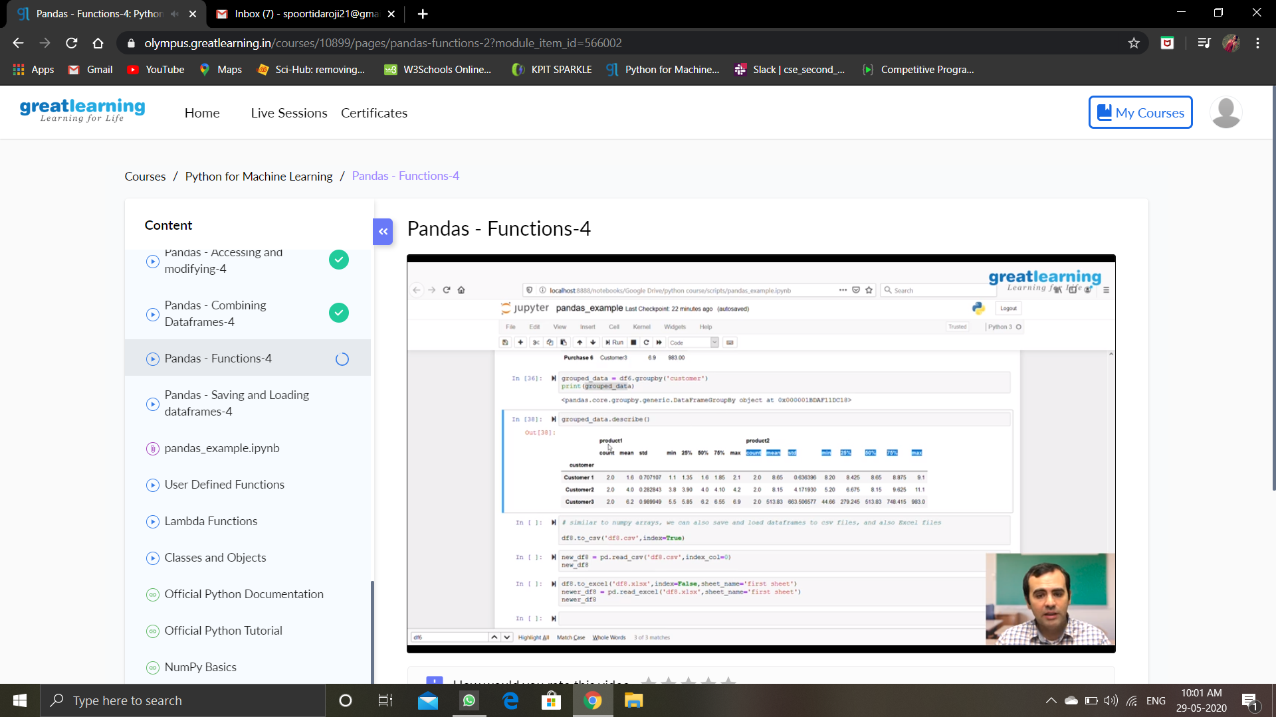

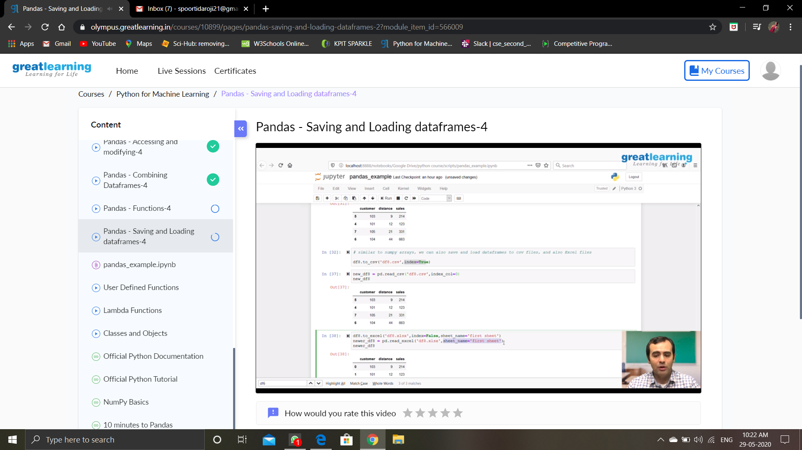

**User defined Functions:**

* **A function is a device that groups a set of logically related statements that perform specific tasks.**
* **Functions help to break a program into modular chunks.**
* **Functions help optimize coding by allowing re-use through function call.**

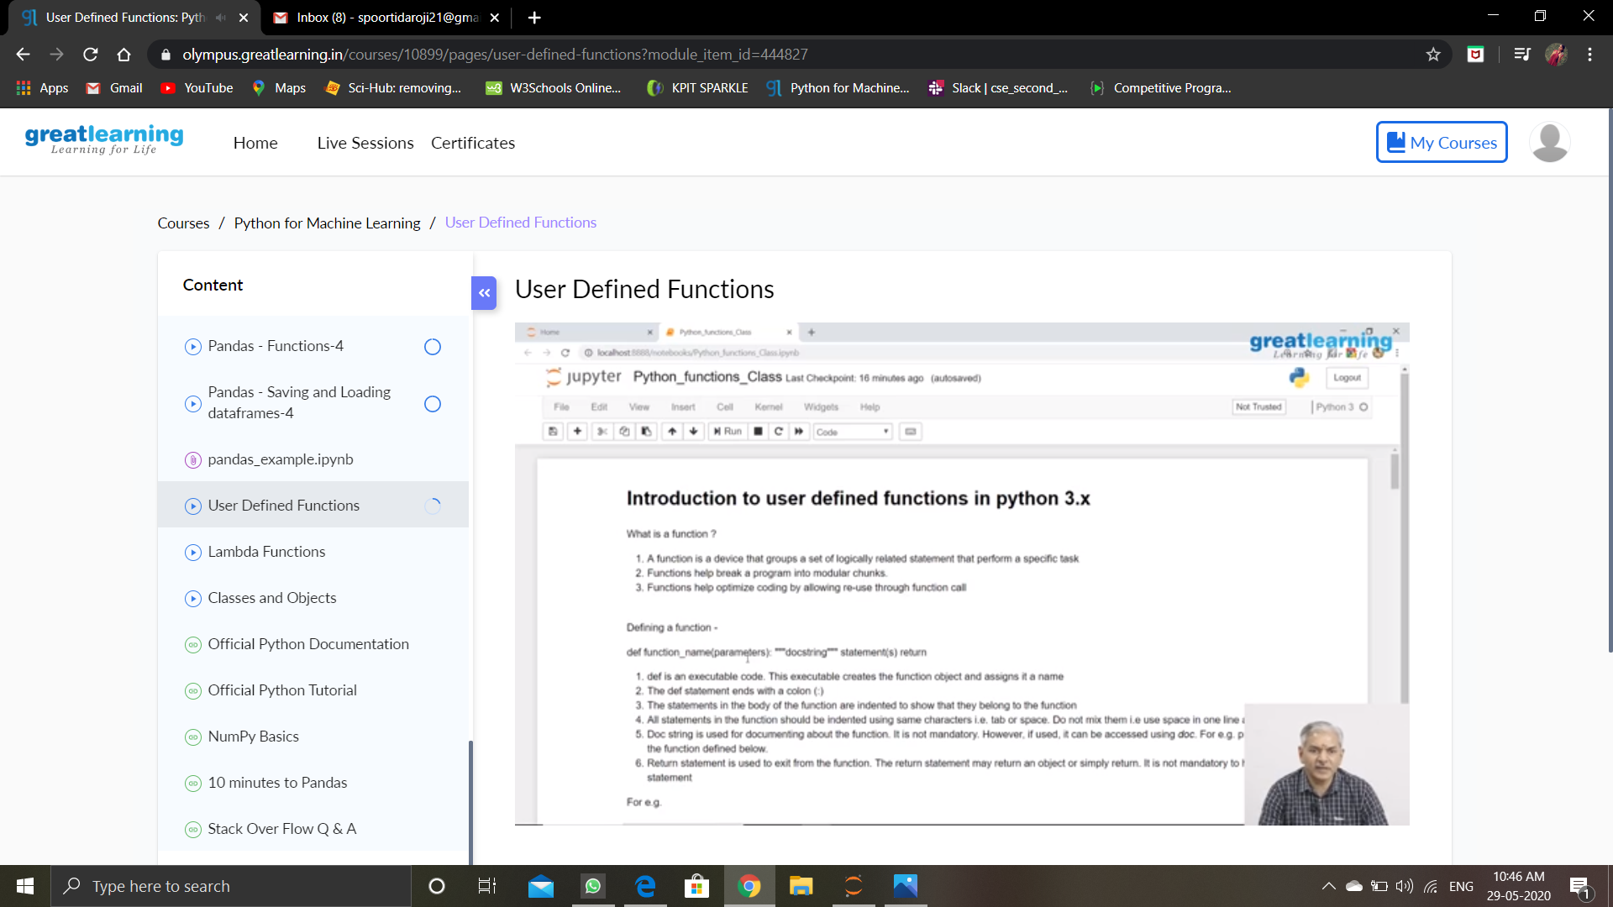

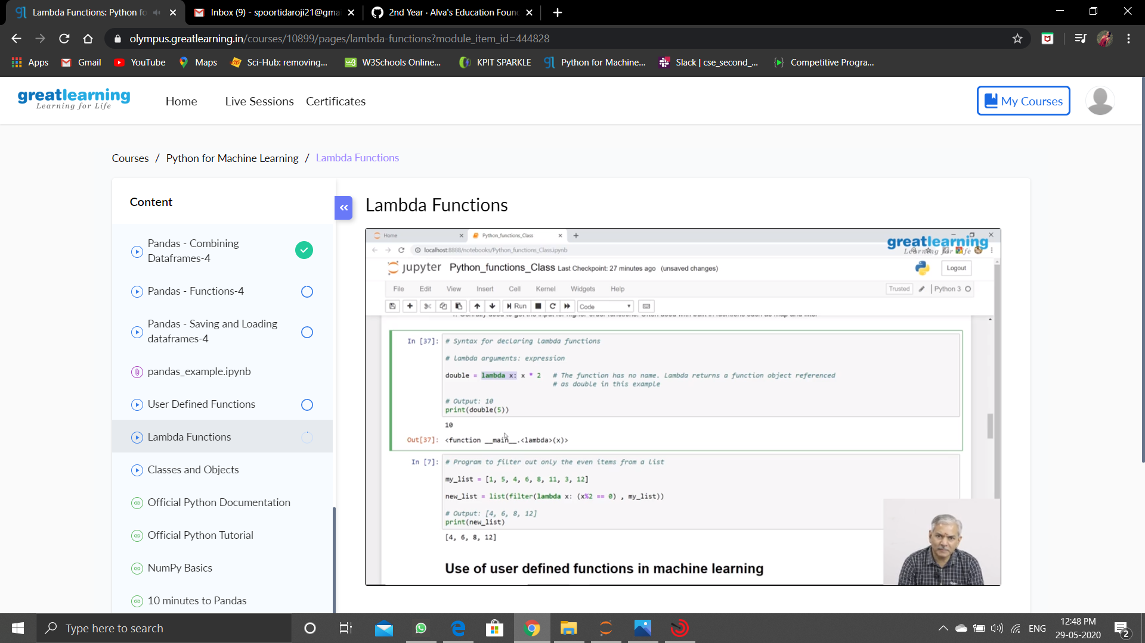

**Online Coding Summary: Today I received the program from prof.Shilpa Hassan CSE Dept.**

**The program is mentioned above in the coding challenges.I have written a program and uploaded it to my Github repository, as shown in the below.**

